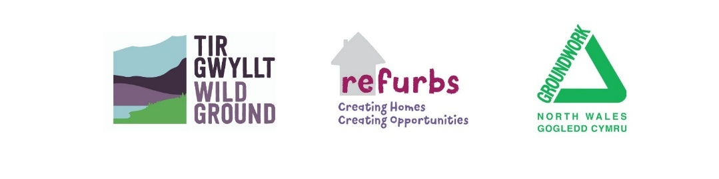

GROUNDWORK NORTH WALES

POLICIES AND PROCEDURES

HR56A COOKIES POLICY

HUMAN RESOURCES POLICY TRACKING SHEET

COOKIES POLICY
Action | Date | Author | Section Modified  (page no/paragraph) |  | Reason for Change
Separation from general Privacy Notice | 22/04/2026 | Victoria Potter |  |  | Approved

Signed: Chair

Print: Date:

Signed: Company Secretary

Print: Date:

Cookie policy

Introduction
This Cookie Policy explains how Groundwork North Wales uses cookies and similar technologies when you visit our website or interact with our online content. It should be read alongside our Privacy Notice (https://groundworknorthwales.org.uk/about/privacy-cookies-policies/ ), which explains how we use personal data more broadly.
Cookies are small text files that are placed on your device when you visit a website. They help websites function properly, improve user experience, and provide information about how the site is used.

How we use cookies
We use cookies to:
- ensure our website functions correctly;
- understand how visitors use our website so we can improve it;
- support our communications and digital services.
We do not maintain a fixed list of individual cookies as these may change from time to time. Instead, we explain the categories of cookies we use, their purpose, and who provides them, to ensure the information remains accurate and meaningful in line with ICO guidance.

Categories of cookies we use
1. Strictly necessary cookies
These cookies are essential for the website to work properly. They enable core functionality such as page navigation, security, and access to key features of the site.
Because these cookies are necessary for the website to function, they do not require user consent.

2. Analytics and performance cookies
We use Google Analytics cookies to collect anonymous usage and visitor behaviour information. These cookies collect information such as:
- which pages are visited;
- how long visitors spend on the site;
- the links you click on
- how users arrive at the website;
- device and browser information.
This information is aggregated and used to help us improve the performance and content of our website. Google Analytics cookies may collect online identifiers such as IP addresses and device identifiers.
Where required, analytics cookies will only be set with your consent.
You can find out more about how Google uses data at: Privacy Policy – Privacy & Terms – Google

3. Email tracking and newsletters
We use Glow and Mailchimp to send newsletters and email communications. Emails sent via these platforms may include tracking technologies (such as tracking pixels) that help us understand how recipients interact with our emails, for example whether an email has been opened or a link clicked.
This information helps us assess engagement and improve future communications. You can unsubscribe from our emails at any time using the link provided in every message.

4. Event booking/Payments cookies
When you book events through Eventbrite, cookies may be set by Eventbrite to enable booking functionality, payment processing, analytics, and security. These cookies are controlled by Eventbrite and are subject to their own privacy and cookie policies.
You can find out more here: Eventbrite Privacy Policy | Eventbrite Help Centre
Where payments are made via Stripe, cookies or similar technologies may be used by Stripe to enable secure payment processing and fraud prevention. These cookies are strictly necessary and are controlled by Stripe in accordance with their own privacy and cookie policies.
You can find out more here: Privacy Policy

Managing your cookie preferences
Where required, we will ask for your consent before using non-essential cookies. You can control or delete cookies through your browser settings. Please note that disabling some cookies may impact the functionality of the website.
Guidance for managing cookies in common browsers can be found at:
- Chrome: https://support.google.com/chrome/answer/95647
- Firefox: https://support.mozilla.org/en-US/kb/enable-and-disable-cookies-website-preferences
- Safari: https://support.apple.com/guide/safari/manage-cookies-and-website-data-sfri11471/mac
- Edge: https://privacy.microsoft.com/en-gb/windows-10-microsoft-edge-and-privacy
You can delete the cookies stored on your computer at any time.

Changes to this Cookie Policy
We may update this Cookie Policy from time to time to reflect changes in technology, legislation, or how we use cookies. Any updates will be published on this page.

Contact us
If you have any questions about our use of cookies, please contact us:
- Email: info@groundworknorthwales.org.uk
- Telephone: 01978 757524
- Address: 3–4 Plas Power Road, Tanyfron, Wrexham, LL11 5SZ

